http://www.flightglobal.com/articles/2009/07/20/329849/thielert-acts-to-rebuild-tattered-reputation.html

DATE:20/07/09
SOURCE:Flight International
Thielert acts to rebuild tattered reputation
By Murdo Morrison

Thielert Aircraft Engines has languished in insolvency protection for over a year, but it is slowly rebuilding its tattered reputation in the general aviation market - even though the German company seems little closer to finding a buyer.
The world's only manufacturer of a certificated kerosene piston engine - under the control of a court-appointed insolvency administrator since April 2008 - says it is on track to increase the working life of its Centurion 2.0 powerplant to 1,500h by the end of the year and 1,800h by the second quarter of 2010.
At the moment, the engine has to be replaced after 1,200h.
"It is very important for us to have 1,800h very fast," says Jasper Wolffson, chairman of Thielert's recently spun-off sales operation Centurion Aircraft Engines. "Our goal is to eventually reach 2,400h."
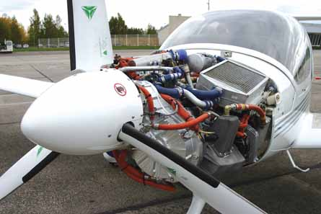
This is highly significant for a manufacturer whose failure to make its innovative and highly economical engines more reliable, and the need to back them up with expensive warranties, were a major contributor to its collapse into insolvency, despite a sales tally of almost 2,500 units.
The company has also this month obtained approval for its engines to use Russian standard TS-1 aviation fuel, allowing Thielert-powered aircraft to operate more easily throughout the CIS. "With this certification, we can open up a huge new market with enormous potential," says Wolffson.
Thielert, until last year, powered diesel versions of Diamond Aircraft's piston-single DA40 and DA42 twin - its only general aviation original equipment customer - and offered retrofits on Cessna 172 Skyhawk and Piper PA-28 Cherokee aircraft.
Winning a new OE customer is another priority. Although Centurion is still delivering to Diamond in small volumes, the Austrian airframer is offering its own Austro diesel engine on its products.
Cessna had agreed to offer new factory-fitted Thielert-powered versions of its 172 from 2008, but the Wichita manufacturer has put a decision on hold until a new investor is found, says Wolffson.
Thielert is still producing engines at its factories in Liechtenstein and Altenburg in eastern Germany.
Wolffson acknowledges that Thielert's insolvency came under much criticism among Thielert engine owners.
However, he says that operators are being won over: "Customers see that we have made a lot of effort to reduce our prices and increase the engines' lifetimes."

